JOINT MEDIA RELEASE
Date: | January 19th 2022, Thunder Bay, Ontario
To: | ALL MEDIA
CONTACT PERSON: | LESLIE BODE-NATIONAL TEAM DEVELOPMENT CENTRE MANAGER  (807) 631-7983, ntdc.manager@gmail.com  Photo Attached: - Credit: Nathaniel Mah/Nordiq Canada  - Sarah Cullinan photo credit to Doug Stephen  - Max Hollmann photo credit to Doug Stephen

For Immediate Release
January 19, 2022

Thunder Bay Skiers off to Europe to compete in World Junior/U23 Championships

The National Team Development Centre (NTDC) and Big Thunder Nordic Ski Club are pleased to announce that three Thunder Bay based athletes have been selected to Canada’s 2022 World Junior and U23 Ski Championship Team. This year’s Championship is being held in Lynga, Norway February 22 to February 27, 2022.

NTDC athlete Pierre Grall-Johnson, who lives and trains in Thunder Bay (home club/town: Nakkertok Nordic/Ottawa), secured his position on the team following exceptional races at the Canadian U23/Junior Trials in Canmore earlier this month with a 3rd place in the Sprint-Freestyle event.
NTDC Head Coach, Timo Puiras, will also be joining the Team as a coach supporting the entire Canadian contingent (Nordiq Canada) at these races. Puiras notes that "we are excited to be going to Norway for these championships. The team has been training well and we are expecting good results."

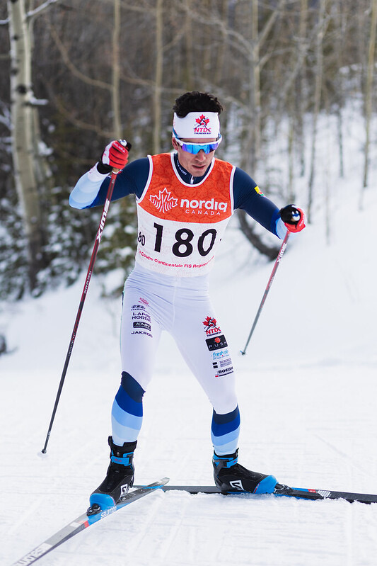

Big Thunder Nordic Ski Club athletes Sarah Cullinan and Max Hollmann were also selected to represent Canada at the World Junior Ski Championships, securing their respective spots with podium finishes in the classic technique races on day 2 of the trial races competition. Cullinan, a grade 12 student at Superior Collegiate, and Hollmann, a second-year physics major at Lakehead University, grew up training in Thunder Bay and will compete internationally for the first time in their young racing careers.

Big Thunder Nordic Ski Club Head Coach Adam Kates said of the athletes’ performance; “it was great to see Max and Sarah achieve such huge personal and team success after so much hard work and dedication leading up to these races. Both stayed extremely focused and motivated during the challenges of a pandemic and both performed to their full potential on the day they needed to. The ski community is very proud of what they accomplished but also of the character and class they show as role models for the next generation of local ski racers.”

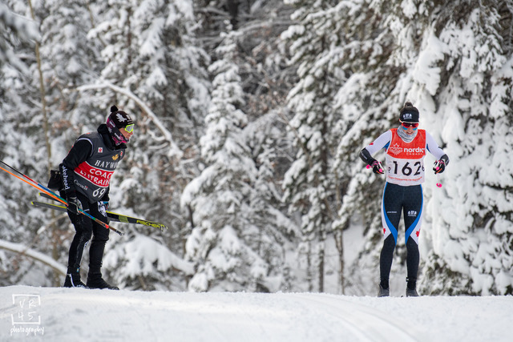
Sarah Cullinan, Big Thunder Nordic Ski Club, Charging Hard to a Silver Medal in the Women’s U20 10km Classic Race and securing her spot on the Canadian World Junior Championship Team. (Photo Credit Doug Stephen)

NTDC Team manager, Leslie Bode noted that “It is inspiring for all the young and aspiring skiers training on Thunder Bay’s fantastic local trails to see these athletes head out to the biggest races in the world. Our ski community, clubs and sponsors, including Cross Country Ski Ontario, play a huge part in supporting and developing the next generation of athletes”.

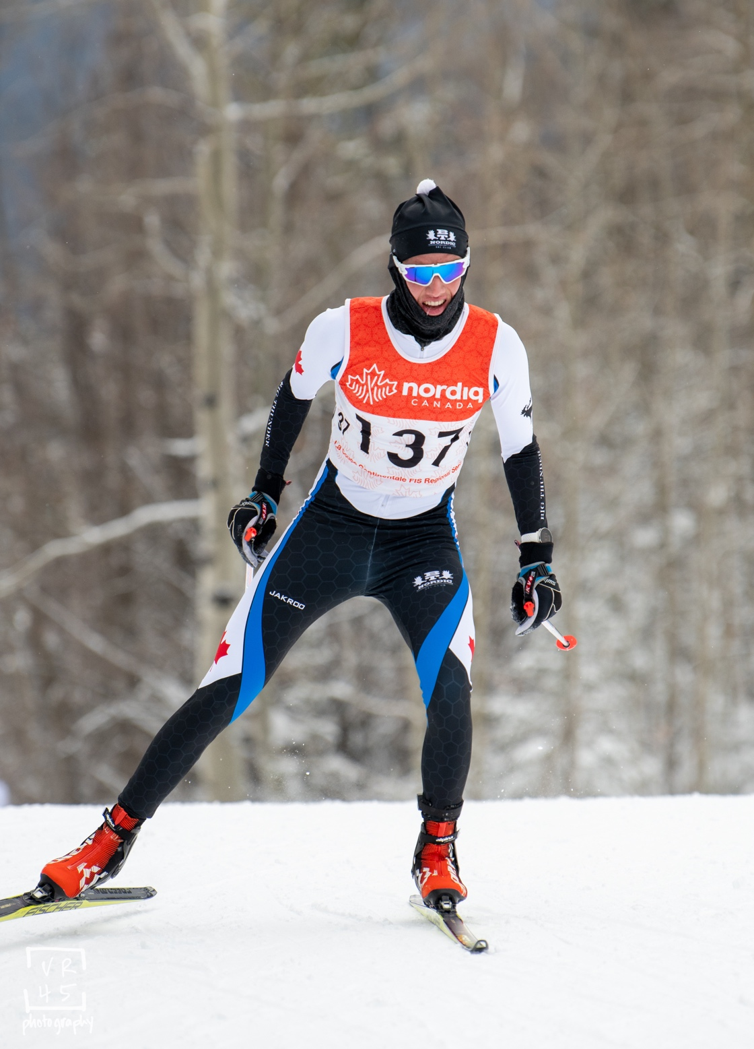
Max Hollmann, Big Thunder Nordic Ski Club, in the Men’s U20 Skate Race in Canmore (Photo Credit Doug Stephen)

Official announcement of the 2022 World Junior and U23 Ski Championship Team can be found at:
https://nordiqcanada.ca/news-item/2022-world-junior-and-u23-world-ski-championships-team-selection/

-30-

