MEDIA RELEASE
Date: | January 14th 2022, Thunder Bay, Ontario
To: | ALL MEDIA
CONTACT PERSON: | LESLIE BODE-NATIONAL TEAM DEVELOPMENT CENTRE MANAGER  (807) 631-7983, ntdc.manager@gmail.com  Photo of Graham Ritchie Attached: -Credit: Nathaniel Mah/Nordiq Canada
For immediate release:

Thunder Bay’s own National Development Team Centre athletes headed to the Olympics!

The National Development Training Centre (NTDC), based in Thunder Bay, is pleased to announce that team member Graham Ritchie (Parry Sound, ON), who lives and trains in Thunder Bay, has been selected to represent Canada in the upcoming 2022 Olympics in Beijing, China.

Following last week’s Canadian Olympic Trial races in Canmore, Alberta, Nordiq Canada and the Canadian Olympic Committee have announced the four women and three men who will form Canada’s cross-country skiing team to compete at Beijing 2022.

NTDC Head Coach Timo Puiras is also pleased to note that among those selected is another former athlete, Katherine Stewart-Jones (Chelsea, QC.), who trained with the team for four seasons (2015-2019).

Ritchie secured his spot with a top-20 and a top-30 result, including a career-best 17th-place finish on the World Cup circuit over the past two seasons. Olympic teammate Antoine Cyr and Ritchie teamed up to finish seventh in the team sprint at the 2021 FIS Nordic World Ski Championships.

Puiras noted "the entire team is very proud of Graham's accomplishment, and I think Graham would be the first to say that it was the day-to-day training with his teammates and backing from NTDC's Integrated Support Team that has helped him achieve this goal."

NTDC Team manager, Leslie Bode noted that “It is inspiring for all of our young and aspiring skiers to see NTDC athletes like Ritchie train on Thunder Bay’s fantastic local trails (Lappe Ski Centre and Thunder Bay Nordic Trails) and work their way all the way up to the Olympics. Our ski community and sponsors, including Cross Country Ski Ontario play a huge part in supporting and developing the next generation of Olympians”.

Olympic cross-country skiing events will take place February 5 to February 20 (Day 2 to 16) at the Zhangjiakou Cross Country Centre.
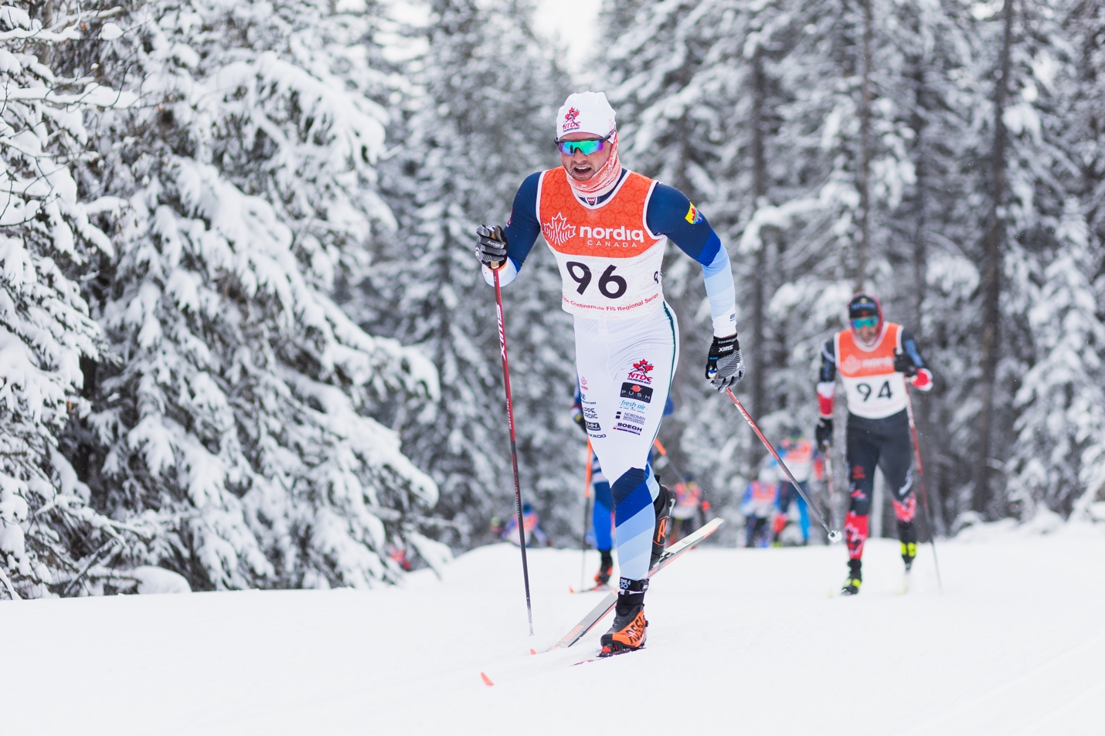
Graham Ritchie_Photo Credit: Nathaniel Mah/Nordiq Canada

