

FOR IMMEDIATE RELEASE

NATIONAL SKI TEAM JOINS NTDC THUNDER BAY SKIERS FOR FALL TRAINING CAMP

October 7 – Thunder Bay

The Canadian National Ski Team (NST) (cross country) has been in Thunder Bay over the past two weeks attending an intensive 12 day fall training camp hosted by the National Team Development Center (NTDC). The camp brought together Canada’s top nordic skiers as they put in their final preparations before the ski season, and featured Nordiq Canada National Team coaches Erik Braten and Katie McMahon, as well as NTDC Head Coach Timo Puiras.

National Team Head Coach Erik Braten was pleased with his first visit to Thunder Bay. “I have been super impressed by the ski community here. There are lots of volunteers ready to go at any time, knowledgeable coaches and staff, and most importantly, hard working athletes. Our skiers have had extremely valuable training here together with the NTDC, and I am so happy we have programs like the National Team Development Centre that develop great athletes to the National Team”.

Two local NTDC skiers (Julian Smith and Graham Ritchie) are members of the National Ski Team and based out of the NTDC program in Thunder Bay. Five other National Team skiers joined NTDC’s 10 members for an intense program of preseason training activities such as rollerskiing, running, skiwalking and strength conditioning.

In addition, the athletes and coaches of both teams have been reaching out to up-and-coming skiers of all ages. The NST and NTDC skiers participated in a Kamview trail run, and led rollerski technique sessions for local Big Thunder, Lappe and Lakehead University skiers. Members of the Ontario Ski Team and local clubs also joined for a weekend Supercamp. The Supercamp, coordinated by Ontario Coach Victor Wiltman, was attended by over 50 skiers and coaches, and included a supper and Q & A session with the National Ski Team athletes and coaches.

The outreach is part of an effort by NTDC and Nordiq Canada to work with the Thunder Bay community and grow participation in cross country skiing. “Canada may not be a super power in the cross country world” explains Braten, “but it is strong communities like this that will keep this sport growing, and show as many people as possible the joy of cross country skiing”.

In November both the NTDC and NST teams, and will collect in Canmore AB for early season on snow training. Then the NTDC athletes will return to Thunder Bay for their annual Nordicfest fundraiser dinner, held November 23 at the Royal Canadian Legion on Van Norman Street, before heading out for the winter race season.
For more information contact:

Heather Foster
fosterbode@tbaytel.net
807-629-3489
- 30 -

4 Images attached

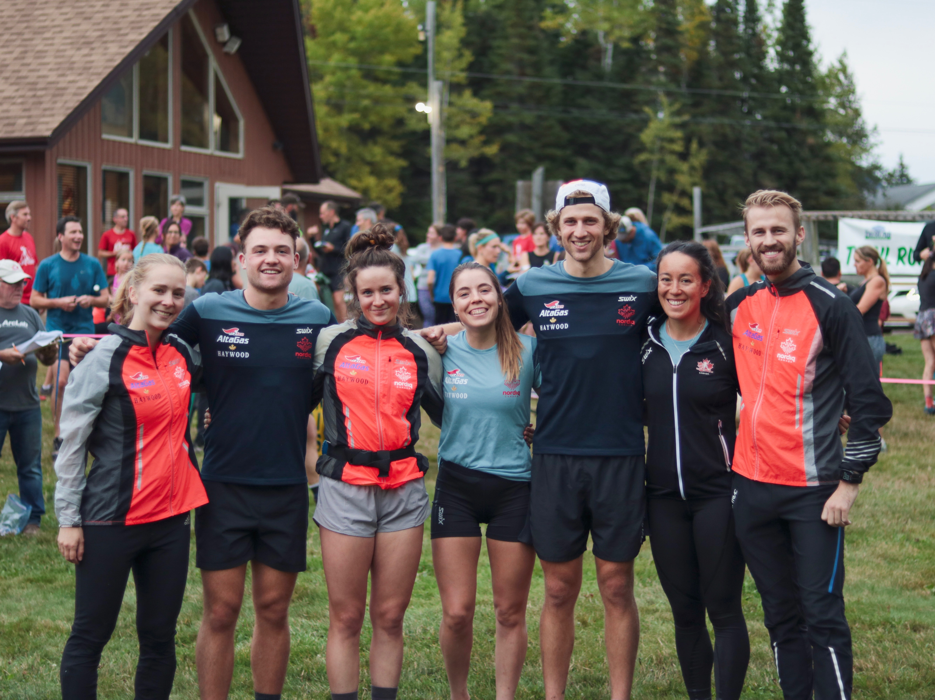
Title: NST at Kamview Trail Run
Caption: National Ski Team athletes and coaches joining runners at the Kamview trail run. (left to right : Katie McMahon assistant coach, Graham Ritchie NST/NTDC, Anna Pryce NST, Katherine Stewart Jones NST, Julian Smith NST/NTDC, Emily Nishikawa NST, Erik Braten NST Head Coach)
Photo Credit: Angus Foster

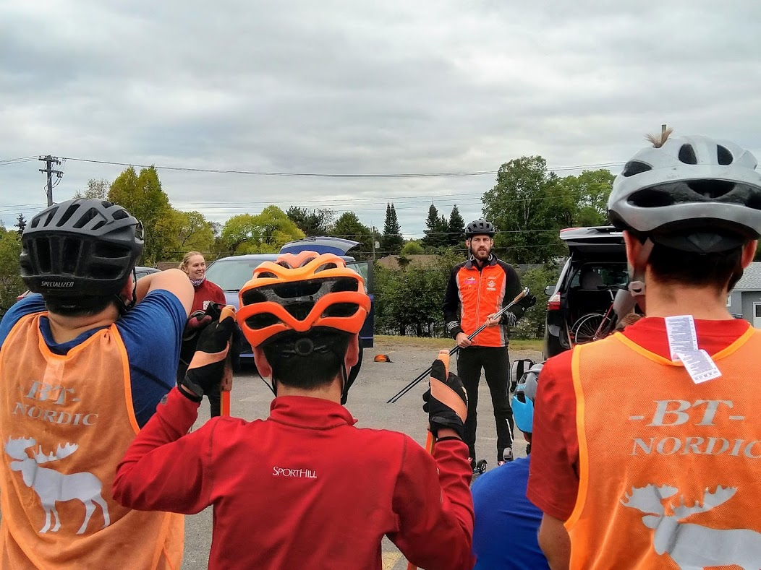

Title: Image – NST Coach and Young Skiers
Caption: National Ski Team coach Erik Braten reviewing rollerski technique with young local club skiers.
Photo Credit: Victor Wiltman

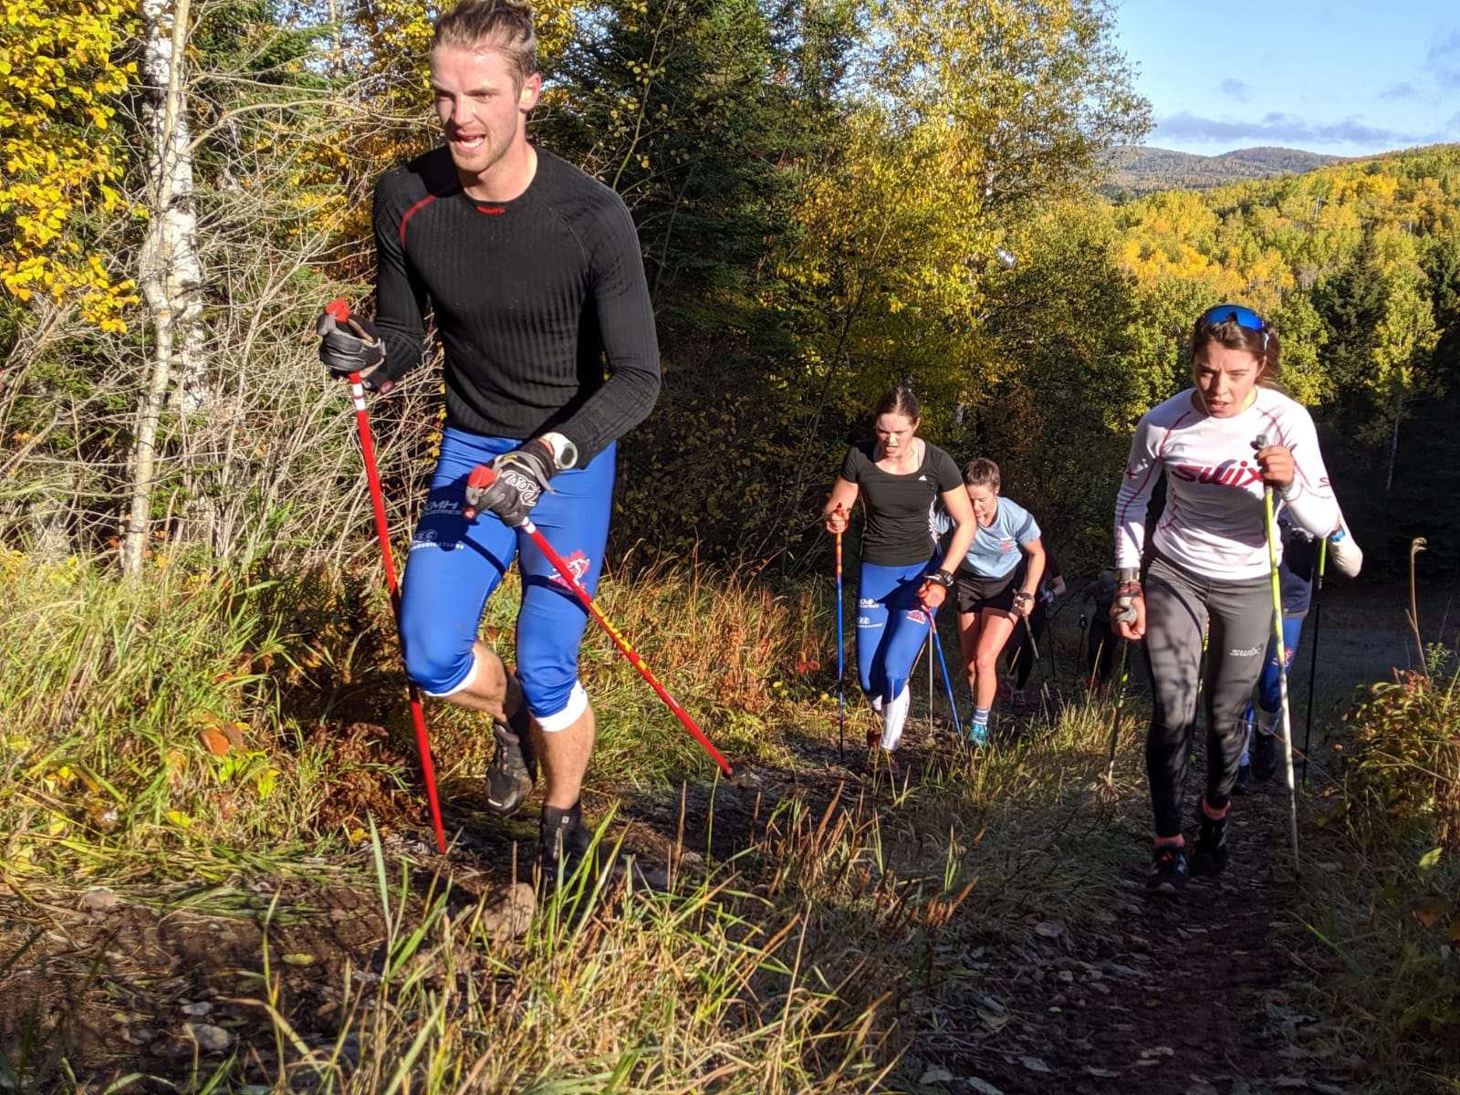

Title: Image – Group uphill.
Caption: Fergus Foster, Shaylynn Loewen, Anna Pryce and Katherine Stewart-Jones hammering the uphill at Mount Baldy.
Photo Credit: John Lindfors

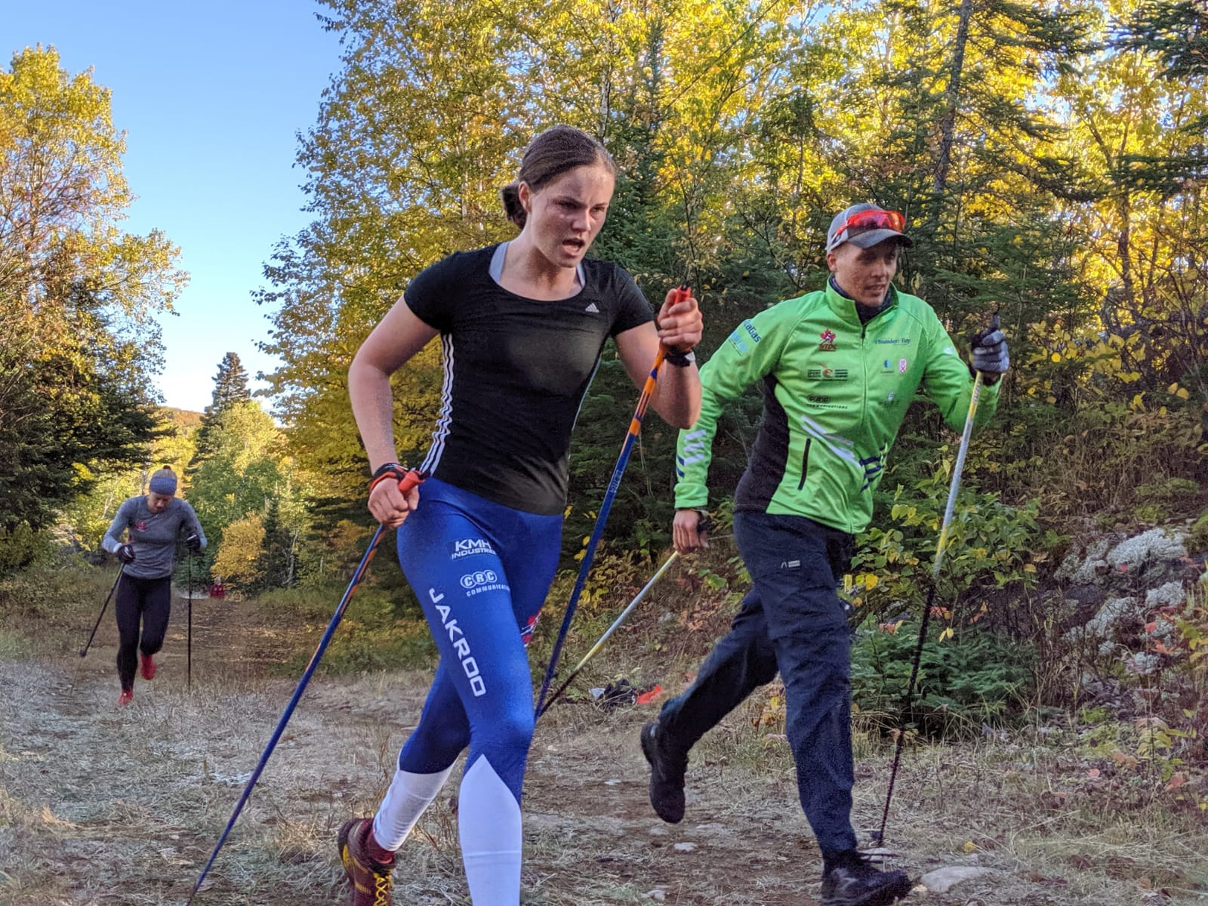

Title: Image – Shaylynn Loewen
Caption: Shaylynn Loewen ski striding up Mount Baldy with NTDC coach Timo Puiras.
Photo Credit: John Lindfors

